Rolsa Technologies
This is Task 1b of Rolsa Technologies – Design Documents

Table of Contents
Interface Design 3
Sitemap 3
Mock-ups 3
Data requirements 3
Data dictionary 3
Entity-relationship diagram 3
Algorithm Designs 3
Test Strategy 3

Interface Design

Sitemap
The sitemap is pictured below, as well as being available as a high quality image under assets/Sitemap.png
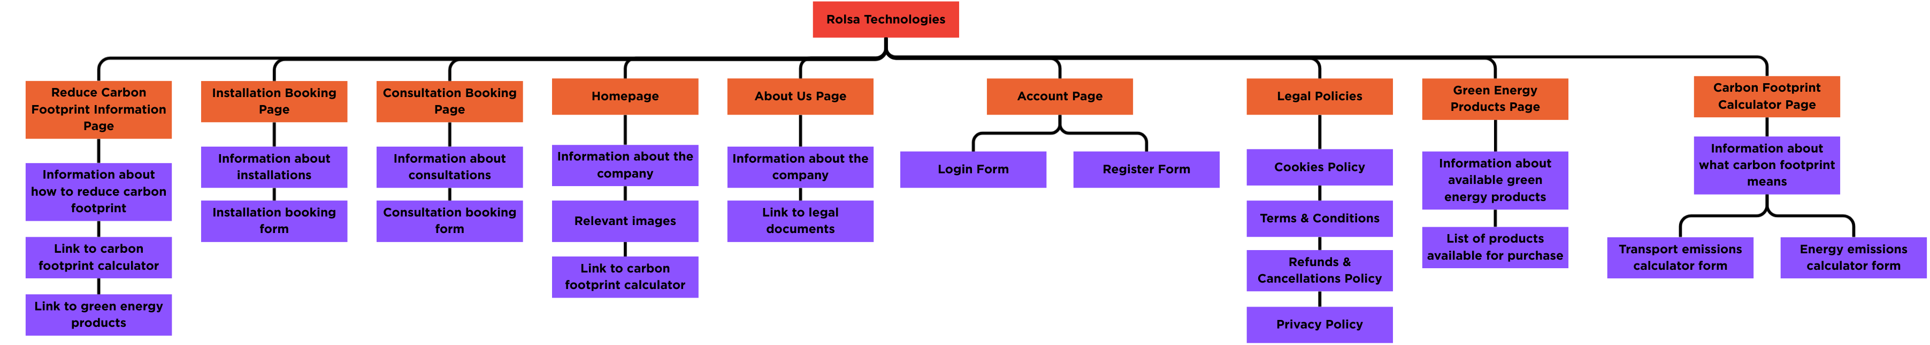

Mock-ups

Data requirements

Data dictionary

Entity-relationship diagram

Algorithm Designs

Test Strategy

